🧰 What Equipment Managers and Plant Supervisors Value Most About YUEDU Shredders

Built for the people who make production happen.
YUEDU Shredders — Trusted by Engineers and Plant Supervisors
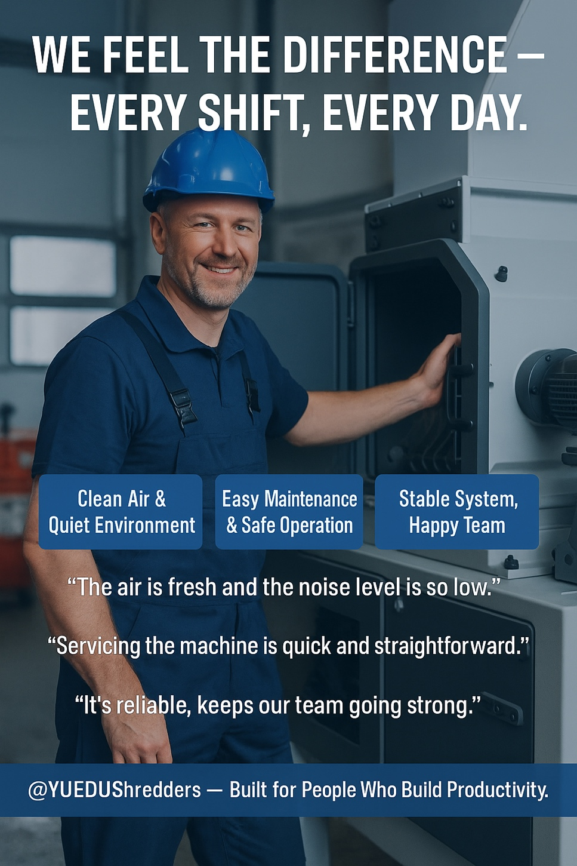
Every YUEDU shredder starts with one simple idea — make life easier for the people who use it.
From cleaner air and quieter workshops to smoother operation, everything is built to help your team work better, safer, and with less stress.
Dimension | Pain Points | YUEDU Shredders – Design Advantages | Benefits for On-Site Personnel
① Environmental & Health Risk Control · EHS Compliance | Conventional shredders often release heavy dust and loud noise — especially when processing glass-fiber or carbon-fiber materials. Airborne particles cause respiratory irritation, skin allergies, and fatigue. Workers operate in dusty, noisy workshops and often say they “earn money at the cost of their health.” | Fully enclosed structure with dual-layer dust- and noise-proof housing, high-efficiency dust collection system, and static-elimination module. Dust leakage is almost zero; noise level stays below 68 dB, fully meeting ISO and global EHS occupational health standards. | Clean air and low noise create a healthier and more comfortable workspace. Employees are better protected, complaints decrease, and the plant image improves. Equipment managers no longer worry about dust hazards, and supervisors easily pass EHS and environmental inspections.
② Production Efficiency & Team Morale | Conventional shredders frequently jam, fail, and require complicated maintenance. Operators spend their days “putting out fires,” while dust and noise cause fatigue and frustration, leading to low morale and unstable production. | High-stability system design with intelligent protection logic and modular structure. Easy operation, quick maintenance, smooth running, fast shredding, low noise, and dust-free performance. | A cleaner and quieter workshop where operation is effortless. With fewer breakdowns and cleaner air, morale and efficiency rise, and management pressure drops. Production rhythm becomes stable, with overall efficiency increasing by more than 20 %.
③ Safety & Operator Friendliness | Many shredders lack safety protection; during maintenance, operators risk electric shock, hand injury, or accidental start-up. | Equipped with safety interlock switches, emergency stop buttons, door-lock protection, and visual windows. Certified under CE and multinational EHS standards. | Safety incidents are virtually eliminated.  Fully compliant with CE and EHS standards, ensuring operator safety and peace of mind.
④ Ergonomic Maintenance Access | Traditional machines have confined spaces that require bending or crawling into the machine, posing safety and ergonomic risks. | Front-opening maintenance door with ergonomic height; screens and blades can be pulled out directly, allowing maintenance while standing. | Maintenance becomes easier and safer. Spacious access reduces physical strain and workplace injury risk.
⑤ Reliability & Continuous Operation | Conventional designs suffer from vibration, jamming, and bearing wear, leading to frequent downtime and production interruptions. | Reinforced frame, precision-balanced shaft and heavy-duty bearings, and precision dynamic balancing. The entire structure is fully welded and stress-relieved. | Enables stable 24-hour continuous operation, drastically reducing unplanned downtime and maintenance calls while improving machine uptime.
⑥ Blade Durability & Wear Resistance | Standard blades wear quickly and often need replacement every week, causing downtime and high spare-part costs. | High-chromium alloy or high-speed-steel blades customized for each material type. Blade lifespan improved by over 3 times with significantly enhanced wear resistance. | Maintenance intervals are longer, replacement frequency greatly reduced, and maintenance costs cut by more than 60 %.

💬 Customer Voices from the Floor
Real Feedback from the Workshop — What Our Users Say
Role | Customer Quote
👷 Operator , Suzhou Electronics Factory | “I used to wear a mask every day because of the dust. Now I don’t have to. The air feels clean.”
🧑‍🔧 Maintenance Technician | “The modular design saves me hours of work. One person can handle it easily.”
👨‍🏭 Process Engineer , Shanghai Packaging Plant | “Before YUEDU, we stopped production twice a week. Now it runs for months without issues.”
👨‍💼 Plant Manager, NJ Energy | “Cleaner, quieter, and safer — the workers are happier, and the numbers prove it.”
🏭 General Manager, MNC | “YUEDU made our plant not only more efficient, but also more human.”

🧠 On-Site Summary
For Plant Supervisors & Equipment Managers:
YUEDU shredders are Environmental friendly, ergonomic, durable, and operator-friendly.
Less downtime, less labor, more uptime — empowering frontline efficiency and safety.

At @YUEDUShredders, we design machines around people — because safe, confident operators build stronger factories.

🌐 Contact Us
Shanghai YUEDU Technology Co., Ltd.
📞 Contact Us to explore more customized models and tailored shredding solutions that suit your specific needs!
Let us help you find the perfect equipment for your application.
📱 Sales Supervisor: +86 159 0178 2779 (WhatsApp / WeChat / Facebook)
📱 Administrative Supervisor: +86 137 6138 5116
📧 Email: yuedushredders@gmail.com | denghao8410@gmail.com
🌐 Website: www.yuedushredders.com
@YUEDUShredders – Empowering Global Industries with Intelligent Destruction Systems.

